

BERZIET UNIVERSITY

FACULTY OF ENGINEERING AND TECHNOLOGY

DEPARTMENT OF ELECTRICAL AND COMPUTER ENGINEERING

**Spectrum Efficiency, Energy Efficiency, and Load Balancing User Association in 5G Heterogenous Network**

Prepared by:

|  |  |
| --- | --- |
| Rajaie Imseeh | 1140302 |
| Mousa Mousa | 1141026 |
| Osama Muhammad | 1140136 |

Supervised by: Dr. Aziz Qaroush

Graduation Project submitted to the Department of Electrical

and Computer Engineering in partial fulfillment of the requirements

for the degree of B.Sc. in Computer Engineering

BIRZEIT

May - 2018

**ملخص المشروع**

خلال السنين الماضية, عدد البشر الذين يستخدمون الهواتف النقالة ووسائل الاتصال آخد بالازدياد بشكل كبير ومستمر, وبالتالي ازدياد كمية البيانات المتناقلة على شبكات الاتصال مما ادى الى زيادة في استهلاك الطاقة عند المستخدمين وضغط أكبر على الموارد المستخدمة, هذا بدوره ادى الى مشكلة حقيقة للمستخدمين والشركات التي اصبحت غير قادرة على استيعاب هذا الكم الهائل من المستخدمين وتقديم خدمة ذات جودة عالية, لذلك توجب البحث عن حلول وبدائل للطرق المستخدمة سابقة بحيث تحقق جودة خدمة جيدة من وجهة نظر المستخدم و تسمح للشركات باستيعاب قدر اكبر من المستخدمين وباسعار منخفضة عن طريق توزيع المستخدمين بشكل يحقق اعلى كفاءة ممكنة للشبكة.

الشبكات المستخدمة سابقا مثل شبكات الجيل الرابع كان يتم تمثيلها بخلية واحد كبيرة يتم توزيع المستخدمين عليها, اما الحل المقترح في شبكات الجيل الخامس فهي عبارة عن اضافة خلايا صغيرة يتم توزيعها واختيار مواقعها حول الخلية الكبيرة بطرق مدروسة بحيث يتم توزيع المستخدمين على هذه الخلايا بطرق معينة لتحقق كفاءة اعلى على الشبكة وخدمة افضل لدى المستخدمين وزيادة القدرة الاستيعابية من وجهة نظر الشركات المقدمة للخدمة.

في هذا المشروع سوف نقوم بدراسة بعض الطرق المستخدمة في توزيع المستخدمين على شبكات الجيل الخامس عن طريق تحقيق عدة اهداف منها تقليل الطاقة المستخدمة من الهواتف عند المسخدمين وتحقيق سعة أكبر في عدد المستخدمين لدى الشركات وبالتالي زيادة ارباحها وتوزيع المستخدمين على الخلايا بحيث لا تتعرض خلية لازدحام كبير في عدد مستخدميها ولا تحرم المستخدم من الخدمة. وسيتم دراسة طرق عدة لتحقيق هذه اللاهداف مثل: نظرية اللعبة في توزيع المستخدمين على الشبكة, نظرية الجينات لانتاج وتحسين حلول جديدة.

في النهاية سوف نقوم بعرض مقارنات للنتائج بين كل طريقة وأخرى ونقوم بعرض الننائج التي تحصلنا عليها مع أناس آخرين قاموا بالعمل على نفس هذا المشروع ونقوم بعرض التشابه والاختلافات فيما تحصلنا عليه وفيما تحصل عليه غيرنا.

**Abstract**

Through the last years, mobile users and data transmission has been grown enormously, that caused in increasing exponentially in the energy consumption, bandwidth shortage and load imbalance, which became a critical issue for the mobile companies to preserve to carry on the ability of growth to meet their new loads, also to achieve to decrease their electric bill, save bandwidth as much as they can and to balance the incoming connection users on the resources they offer. A heterogeneous network in which old-style well-planned macro cell deployment is covered by a second-tier small-scale base stations is the most common solution for next-generation 5G networks. On the other hand, the current techniques which are used for user association in current networks will not work on the upcoming heterogeneous network. So, finding a new way for the user association problem is an interesting topic for analyses.

This report introduces for some solutions on how to associate the users on the best base station in 5G heterogeneous network, that’s by achieving multiple objectives as Energy consumption, Bandwidth consumption (denoted by the SINR) and load balancing of users. So, this project defines the problem of user association as multi objective problem and defines some new techniques for associating the users. These techniques are listed by the following algorithms; Greedy Algorithm, Game Theory Algorithm, Single Objective Genetics Algorithm and Multi-Objectives Genetics Algorithms. This project solves the user association problem by these algorithms and compare the results with other algorithms from other related papers.

**Keywords** Heterogeneous cellular network · Macro Cell · Femto Cell · Mobile Users · User association · Energy efficiency · Spectrum efficiency · Load balancing · Optimization.

Table of Contents

Chapter 1 Introduction 1

1.1. Introduction 2

1.2. Motivation and problem statement 3

1.3. Contribution 3

1.4. Report outline 4

Chapter 2 Related Work 5

2.1. Scope 6

2.1.1. Heterogeneous networks (HetNets) 6

2.1.2. Other 5G Candidate Technologies 7

2.1.3. Summary 8

2.2. Optimization techniques 9

2.2.1. Game Theory 9

2.2.2. Evolutionary algorithm 10

2.3. Optimization Metrics 11

2.3.1. Energy efficiency 11

2.3.2. Spectrum Efficiency 13

2.3.3. Load balancing 14

Chapter 3 Proposed Work 15

3.1. Problem definition 16

3.2. System model 16

3.2.1. Power Calculation: 18

3.2.2. SINR Calculation: 19

3.2.3. Throughput: 19

3.3. Problem formulation and solution: 21

3.4. Solving the Problem Using Greedy Single Objective Game Theory Approach 22

3.4.1. Simple Single Objective Greedy Algorithm: 22

3.4.2. Game Theory Algorithm 24

3.4.3. Problem Formalization for Game Theory: 25

3.5. Solving Problem Using Evolutionary algorithm: 27

3.5.1. Problem Formalization for Evolutionary Genetics: 27

3.5.1.1. Chromosome Formalization: 27

3.5.1.2. Genes Formalization: 27

3.5.1.3. Cross-Over Algorithm: 28

3.5.1.4. Generating population: 28

3.5.1.5. Probability of matting: 29

3.5.1.6. Probability of mutation: 29

3.5.1.7. Fitness Function: 29

3.5.2. Evolutionary Algorithm Based on Single Objective Value: 29

3.5.2.1. Using SINR only: 30

3.5.2.2. Using Power only: 30

3.5.2.3. Using Power and SINR without load balancing: 30

3.5.2.4. Using Power, SINR and Load balancing: 31

3.5.3. Evolutionary Algorithm Based on Multi objective Solution: 31

3.5.3.1. Adding the load balancing to the multi objective solving problem: 32

Chapter 4 Experiments and Results 33

4.1. Simulation Tool: 34

4.2. Experiments setup: 34

4.2.1. Building topology: 34

4.2.2. Simulation Parameters: 35

4.3. Results: 35

4.3.1. Determining the best Macro density 36

4.3.2. The impact of Number of small cells on the total throughput 37

4.3.3. The impact of Number of users on the Energy Efficiency 38

4.3.4. The impact of Area on the EE and SE 39

4.3.5. Flow chart describes the percentage distribution across all macro and femto cells for each optimization technique 40

4.3.6. Run samples for the optimization techniques shows the distribution of users in our topology. 41

4.3.7. Optimization techniques summary 43

Chapter 5 Conclusion 44

References: 46

List of Figures

Figure ‎2.1 Genetics format. 11

Figure ‎3.1 Network Architecture. 17

Figure ‎3.2 Our Chromosome for NSGA-III Algorithm 27

Figure ‎3.3 Our Genes for NSGA-III and genetics Algorithms 28

Figure ‎4.1 Energy efficiency bits/joule Vs. Macro cell density to user density ratio. 36

Figure ‎4.2 Spectral efficiency(bps/Hz) Vs. Macro cell density to user density ratio. 37

Figure ‎4.3 Number of Small Cells Vs Total Throughput all techniques. 37

Figure ‎4.4 Energy Efficiency Vs Number of users all techniques. 38

Figure ‎4.5 Area Vs EE all techniques. 39

Figure ‎4.6 Area Vs SE all techniques. 39

Figure ‎4.7 distribution of near 500 users over macro and femto cells. 40

Figure ‎4.8 the distribution of users using Game Theory approach. 41

Figure ‎4.9 The utility function of Game Theory compared with the normal based line. 41

Figure ‎4.10 the distribution of users using Genetic Single objective. 42

Figure ‎4.11 The distribution of users using NSGA-III. 42

Figure ‎4.12 the distribution of users using Greedy Algorithm . 43

List of Tables

Table ‎2‑1 Comparison between Macro and small cells [2]. 6

Table ‎2‑2 Network topology summary. 8

Table ‎4‑1 MATLAB Classes and description 34

Table ‎4‑2 Parameters Values for Simulation 35

Table ‎4‑3 Optimization techniques summary. 43

# Introduction

## Introduction

Nowadays, the total number of devices that are manufactured around the world are increasing dramatically, and it is predicted that the data traffic density will increase enormously than the current data traffic and all previous technologies cannot handle this massive rise in users and data rate.

The fourth generation of mobile networks for example have some limitations, such as no support for Heterogeneous networks (HetNets), as discussed in [1] which provides a flexible and more economic infrastructure compared with tower-mounted (macro-only) systems. Moreover, there is no sufficient utilization of processing power of base stations, it gives the same power to an area independently of the load upon it. Furthermore, In the current cellular networks, there is no support for zero latency property, in which a user equipment needs hundreds of milliseconds to find the appropriate or best base station to connect to. Moreover, the defect of the current network is that the communication between a user device and an outdoor base station is not efficient in terms of spectrum efficiency, energy efficiency and data rate transfer, due to the environment attenuation on the communication signals.

Most of above problems will be solved in synchronism with the launch of the fifth generation of mobile networks (5G). At the beginning, 5G networks support HetNets which will be our mainly scope in this report. Moreover, 5G networks can give each area its need of power based on the capacity assigned to each base station. On the other hand, for the latency problem, 5G networks are planned to support real time services with optimal quality of service. Furthermore, another requirement is that 5G should support the ubiquitous connectivity and support massive number of connected devices. The requirements of 5G networks we mentioned before may have several challenges as the author in [1] mentioned:

* **Scalability and flexibility:** 5G must be powerful enough to work with massive number of users with their unlimited demands on the network.
* **channel for upload and download link:** We need to manage the channel that is used to transmit and receive data, the time and frequency of it should be controlled very well to accomplish the best possible performance.
* **Environmentally friendly:** Wireless technologies consumes a lot of energy that emits CO2 which defects the environment, so a big challenge is to develop a technology that is friend to the environment.
* **Performance:** 5G is required to reach a big coverage area and serve many devices, with all that it needs to have an excellent performance, and that is a big challenge.
* **Security issues:** 5G shouldn't ignore the privacy wise of users, the capability of making users connect indirectly to the base station by connecting through other users’ needs to take the privacy of users into consideration.

## Motivation and problem statement

Energy sustainability is the key for future networks due to their foreseen capacity upsurge. The most important factor for building a sustainable cellular network is to achieve a high spectral energy efficiency and load balancing without effecting the quality of service (QoS) for the users, in other words without decreasing the total QoS. So, our aim in this project is to maximize the value of these metrics during user association using multi-objectives optimization techniques. The architecture we are going to make our experiments on, consists of two-tier HetNets cellular networks, the first tier is the macro cell tier, this cell has a big coverage area in other words, it uses small frequency ranges. Moreover, it has more transmit power than the other tier. The second tier is the femto cell tier, this tier has a less coverage area in other words, it uses high frequency ranges. Also, it transmits power less than the macro cell tier. Here is a list of objectives that we will work on and described in this report:

* Building dynamic topology of two tier HetNets.
* Making a tradeoff between energy, spectrum and load balancing. Getting the maximum values of these metrics while associating the users.
* Associating the users using many techniques such as greedy algorithm, Game theory algorithm, single objective genetics algorithm and multi-objective genetics algorithm NSGA-III (Non-Dominant-Sort-Genetics-Algorithm).

## Contribution

Most of other related work were working on associating the users based on one single objective while ignoring other objectives, in this project we considered multi-objectives to associate the user to the base station, this technique improved the total throughput of the hole system and improved the total spectrum efficiency, energy efficiency and the load balancing of users on the base stations. The efficiency off the hole system also increased making the users connecting to the femto cell a better choice from connecting to the macro cell, this improved of load balancing the uses on the femto cells while keeping the macro cells for the special need. We also used some new techniques for associating the users as the evolutionary algorithm whether it was single objective or multi objective algorithm.

## Report outline

In chapter 2, section 1 introduce the different types of scopes that can be used in the network, the section describes each type, how it works and why to use them. The section that follow describes the different models used in networks. Section 3 explain the metrics we can work on in our project and describe the calculation of each one.

Chapter 3 defines the problem we are working on very well, with the architecture we used, and all calculation needed to solve the problem, in addition it formulates the problem in different ways as in greedy and genetics algorithm describing the ways we used for solving the problem (associating the users in our topology)

Chapter 4 gives some information about the tool we use, and why did we use it, how it helps us to get the solution and list all parameters we define as inputs. Describe the main directories, classes and scripts we used to solve the problem. Discussion of results and compare it with results of other people.

The last chapter gives a conclusion of the whole work in the paper and how well was our work compared with others work.

# Related Work

This chapter gives a briefly summary about the topology, models and metrics of the 5G network architecture, on other hand we will analyze and expand some related works on the user association to multi-objective metrics.

## **Scope**

### Heterogeneous networks (HetNets)

A heterogeneous network is a network the connects different types of devices such as computers, mobiles and other devices even if they have different protocols or operating systems. HetNets is an effective approach to provide the coverage and capacity needed for cellular networks. This type of networks uses small cells in its structure, which will provide more capacity since there will be more users sharing the same spectrum. So, as in [2] this network reduces the coverage of the cell to decrease the capacity shared by users leading to a high capacity and faster data speed. And to know more about the small cells Table ‎2‑1 is a comparison between the macro cells and the small cells.

Table ‑ Comparison between Macro and small cells [2].

|  |  |  |
| --- | --- | --- |
| Features | MACRO CELLS | SMALL CELLS |
| Max User Per Cell | 2000 | 200 |
| Max range | 25Km | 200m |
| Max Transmit Power | 50W | 5W |
| Typical usage | Fast moving and rural coverage | Stationary / slow moving and urban / in-building coverage |

The high capacity is not only the advantage of the small cells used by the HetNets, from Table ‎2‑1 we can see that the small cells transmit at low power, as the author mentioned in [2] that will decrease the cost and by reusing the spectrum across a geographical area which results in spectral and energy efficiency.

Using a dedicated carrier for the small cell layer is the simplest deployment to use. By using it, as proposed in [3] the interference with the macro cell will be reduced to the lowest level and avoid tight coordination or synchronization. On the other hand, there are disadvantages when using dedicated carrier, since there are multiple frequency bands which might not be used most efficiently. In addition, there will be time and power consuming inter-frequency handover needed by the mobility between the frequencies. There will be some drawbacks even if we use another way, like carrier aggregation, in which there will be centralization and complexity problems. As users increase the demand of lower costs and improved performance, the challenges for operators increases requiring a new and wide technologies to ensure the success of the operation of their networks in a variety of scenarios.

### Other 5G Candidate Technologies

There are some other technologies that may enter the race of the evolution in the 5G, and those technologies are:

* Massive MIMO Networks

Massive MIMO (Multiple-Input-Multiple-Output) is a technology that utilizes the active antenna elements that exists in each Base Station to communicate over the same time and frequency band with single antenna terminals. As mentioned in [4, 5] which can serve many users at the same time and this is an advantage over the conventional MIMO that can serve only a very limited number of users. The interference exists between adjacent subsectors of the same site, more likely than between overlapping subsectors at different sites. Thus, backhaul overhead can be reduced due to the less need of cooperation between sites. The main disadvantage of Massive MIMO is its complexity, so it is used mostly for cellular tower.

* MmWave Networks

MmWave is the next generation wireless technology that its data rate is expected to reach 100 times of today's technology as it is described in [6]. Millimeter wave spectrum ( between 30 [GHz](http://searchnetworking.techtarget.com/definition/gigahertz) and 300 GHz) wavelength (10mm-1mm), this spectrum is used for high speed wireless communication, by allocating more bandwidth to speed transmission of files especially high quality video and multimedia content.

* Energy Harvesting Networks

Energy harvesting is the process of extracting energy from energy sources such as wind energy, solar energy and thermal energy. But, as it is proposed in [7] these energies are not stable, they vary over time according to the weather, time and location so we cannot depend on this way of harvesting.

* Device to Device communication (D2D)

A technology that enables devices that are close to each other to communicate directly to improve the energy and spectrum efficiency as mentioned in [7].

* Full Duplex communication

It is a technology that allow the data to transfer in the two ways (Bi-directional) as it was proposed in [7], an example of a full duplex device is the telephone in which you can talk and listen in the same time. This technology improves the spectrum efficiency.

* Cloud radio access network(C-RAN)

As [7] describes it, the cloud contains the baseband unit, so it can coordinate between cells which improves the performance and reduce the cost.

* Self-organizing networks(SONs)

It is an automatic technology that performs planning, healing, configuration and optimizing so that the manual work is reduced [7].

### Summary

From Table ‎2‑2 we notice that each technology has its own benefits, small cells for example that are used in HetNets increase the data transfer and network capacity and it is efficient in terms of energy, in addition that it doesn't need a high cost to be used. Massive MIMO, MMWave, D2D and C-RANS all of them support massive devices. Massive MIMO also has low latency, but it is not costly efficient. CRN increase the capacity of the network and it is costly efficient. MMWave has the same advantages of Massive MIMO but each one of them has its own applications. For device to device(D2D) it is good in economic, energy, data transfer and sportiness of massive devices terms. Energy harvesting networks are efficient in energy and economic terms. SONS have two good domains, data transfer and network capacity increase. At last, we choose to use HetNets because it collects most of the previous benefits.

Table ‑ Network topology summary.

|  |  |  |  |  |  |  |
| --- | --- | --- | --- | --- | --- | --- |
| Mythologies/Technologies | Increase data transfer | Increase  network capacity | Support massive devices | Energy efficient | Low latency | Economic |
| Small cells (HetNets) | X | X |  | X |  | X |
| Massive MIMO | X | X | X | X | X |  |
| CRN |  | X |  |  |  | X |
| D2D | X |  | X | X |  | X |
| mmWave | X | X | X | X | X |  |
| C-RANS | X | X | X | X |  | X |
| Full duplex |  | X |  |  |  |  |
| DUD |  | X |  |  | X |  |
| VLC | X |  |  | X | X | X |
| Energy harvesting |  |  |  | X |  | X |
| SONs | X | X |  |  |  |  |

## Optimization techniques

This means using the Utility in widely range to solve the user association problem, where the utility depending on the metric adopted, may be relied on spectrum efficiency, energy efficiency, QoS, etc.

### Game Theory

"Game theory is a mathematical modeling tool, which has distinct advantages in investigating the interaction of multiple players(Users)" as described in [8]. In game theory there is a point called "equilibrium point" occur when the combination of plans incorporating the best strategy for each user in the system. Game Theory can follow one of following methods:

* Non-Cooperative: Covers competitive social interactions where there will be some winners and some losers between users. Reference [8] identifies the solution of the game achieves Nash Equilibrium (NE) (when all users make the choice that better off and no matter what their opponents decide to do). When the user competitive with others, it makes sense to choose the course of action that benefits himself the most and no matter what everyone else decides to do.
* Cooperative where every user(player) has agreed to work together toward a common goal. A method of dividing up gains or costs among players according to the value of their individual contributions called "Shapley Value" where, the contribution of each user is determined by what is gained or lost by removing them from the game and this is called (marginal contribution) as the author in [8] defines. And if two parties bring the same things to the coalition they should have to contribute the same amount and should be rewarded for their contributions equally. Also, for Dunny players who have zero value: where if a member (user) of a coalition contribute nothing then it should receive nothing. And in some cases, where the user can’t contribute at that moment, in that case the coalition might want to pay something out to them anyway. Although, if a game has multiple parts, Cost or Payment it should be decomposed across those parts.

We need to mention that the game theory is a good way to design distributed algorithms with flexible self-configuration features but may imposing a low communication overhead. Moreover, game theory operates under the assumption of rationality, where in 5G networks, players — BSs or users — may cannot be act in a rational manner all the time.

Game theory may have some challenges as enhancing the NE efficiency, while bargaining ensures the highest level of fairness among the users. In addition, the distributed method that finds a NE nearer from the social-optimum point is the repeated game but can have two practical drawbacks as [8] mentions which are the unacceptable latency due to high number of repetitions and not finding[9] the social-optimum solution due to incomplete system information.

### Evolutionary algorithm

Genetic Algorithm is an optimization method inspired by the process of natural selection that belongs to the evolutionary algorithms, as [9] defines genetic algorithm (GA) by generating an initial population which will be used for crossover and mutation, this initial population must have diversity to generate a new population and to reach a global maximum solution rather than being stuck in local maximum solution. Each chromosome represents a solution to the problem, and the fitness value which is calculated from the fitness function indicates how good is this solution from other solutions. To search a global maxima or minima (depending on the problem itself), the generic operations such as crossover, mutation and selection can be performed during each iteration which in this way will generate a new generation with new fitness values that is desired to be better than the old generations. Where the crossover operation is a matting between a selected two chromosomes (parents) that may generate a new two chromosomes (children) that can have better characteristics than the parents’ chromosomes. The mutation operation is an unnatural changing in the genes of the chromosomes while being mated, this unnatural change may produce better solutions or may produce worst solutions this may get a new combination of genes. This helps to make diversity in the genes if there no diversity and to get out of local minima or maxima.

When encoding process, each chromosome should be represented in such a way that it provides complete information about the solution of problem represented in the form of a binary as shown in Figure ‎2.1 [9].

|  |  |  |  |  |  |  |  |  |  |  |  |  |  |  |  |  |
| --- | --- | --- | --- | --- | --- | --- | --- | --- | --- | --- | --- | --- | --- | --- | --- | --- |
| Gene 1 | | | | |  | Gene 2 | | | | | …… | Gene N | | | | |
| 0 | 1 | 0 | 0 | 1 | 1 | 0 | 0 | 1 | 0 | 1 | 1 | 1 | 0 | 1 |

Figure . Genetics format.

To evaluate the fitness value for each chromosome we used a fitness function. The fitness measure determines how well an individual chromosome from the overall population. The fitness function is generally a real number, where as its value increase the chromosome will be closer to the optimal solution. Then a pair of parent chromosomes is selected from this pool and mated using the crossover procedure discussed for our topology in section ‎3.5.1.3. After that we perform the crossover on randomly selected chromosomes by exchange parent chromosomes with each other to get a new child chromosome, which each crossover generates two child chromosomes. Also, a mutation process may occur, while the child chromosomes reflect a bit from 0 to 1 or vice versa. The number of chromosomes that apply the mutation process is specified by the mutation rate (such as 1%).

## Optimization Metrics

In this section we will introduce to some common metrics and the related works that users and companies work on to optimize for optimal user association in 5G network without affecting the QoS for all users.

### Energy efficiency

The energy efficiency metric is one of the most significant metrics in user association algorithms, as governments nowadays are being more concerned about environments and environmental pollution, that’s why many industrially and academically institutions are thinking about saving energy and also changing their viewpoint for switching from solar energy into green energy that is friendly for the environment, also these industrially and academically institutions ;and for a chosen algorithm for user association in a certain scope, they have many choices for an energy efficiency metrics that provides a study for the power saving possible. Two of the main metrics for an energy efficiency are as described in [10].

* The ratio between the total data rate of all users and the total energy consumption (bits/joule).
* The direct presentation of the power/energy saving achieved by means of a certain algorithm. As the percentage of power saving for a certain algorithm.

Now we will discuss the HetNets scope how the energy efficiency can affect the user association:

* Energy efficiency in HETNETS Network

In the HetNets networks, maximizing the energy efficiency can be shown as Minimizing the total energy consumption while satisfying the associated traffic demands. Maximizing the overall energy efficiency; which is defined as the ratio between the total data rate of all users and the total energy consumption of the network.

In HetNets connecting to macrocells will consume more power than connecting to a small cell also when associating to a macrocell will dramatically need larger transmit rate comparing with the small cells. Many researches as [11] aimed for maximizing the downlink and the throughput for user association by associating each mobile with a base station that outcomes in minimizing the transmit power consumption. Also, only a small number of existing researches have considered the joint uplink and downlink user association in HetNets, a user organization plan was projected, and the goal function was prepared as the subjective difference between the total number of established user equipment’s and total summation of uplink transmit power. Also, we want to maximize the sum of log-scale uplink and downlink power efficiencies along with all user equipment’s. In this class of network, the most consuming part is the base station, so one of the most important solutions which is a efficient way to reduce power consumption was by shutting down the base station if no users are connecting to it. So, the user association and the base station sleep mode are the best in maximizing the energy efficiency or minimizing the total power consumption.

### Spectrum Efficiency

The spectrum efficiency is defined by the maximum data that can be transmitted in a defined bandwidth in the communication system network (wired or wireless), for 5G networks a high spectrum efficiency is needed to decrease the traffic of data and the limited resources used for spectrum. Since in 5G networks need to be very fast then this means that a low interference between the base stations and large spectrum bandwidth need to be defined. 5G networks operate on high frequency bands in above 24 GHz which gives it more and more bands to transmit data through and as a result it makes it much faster for transmitting data.

Also, the user allocation algorithm plays a role in the spectrum efficiency as reference [12] described the huge number of mobiles (users) are connecting to the same base-station then this base-station must have a big spectrum to transmit data in an efficient way. It is measured in the number of bits traveled from one place to another on a network at a given carrier frequency and have a unit of (bits/second)/Hz. We will compare for different scopes of network how to allocate the users based on the spectrum efficiency.

* Spectrum Efficiency in HETNETS Network

In this type of network the spectrum allocation is one of the most important metrics, since there is a macro-cell and other small cells and the interference between the cells is high enough which may result in working on a good algorithm to allocate the users on the perfect base-station to minimize the sum of data rate and number of channels, also in this type of network it is known that the number of users allocated on a small cell is much larger than the number of users allocated on a macro-cell so this means we need much number of frequencies to transmit the data on in the small cells, although we need to be careful when associating the users such that minimizing the data rate of all users may result in an inequitable (unfair) data rate allocation. Also, users who are allocated to the macro-cell will achieve higher data rate from users allocated in a small cell this because the users who are allocated to the small cells are much larger than users allocated to the macro-cell.

There are many algorithms to allocate the users on the base stations, such algorithm is low complexity distributed user association that maximize the data rate for all users, in [13] the author gives more resources to the users who has low data rates achieving load balancing and more fairness between users. Another algorithm used to associate the users is Game theory where the base-station is like a player challenging to serve the users to maximize the data rate-based value, while promising a certain minimal data rate for all users, and at the same time giving fairness for all users as well as balancing the traffic load of the cells in different tiers.

### Load balancing

In distributed computers the load balancing term is widely used to balance the tasks among processors this will help to optimize some major metrics as throughput, delay, and resource using, as reference [14] described the load balancing in wireless network especially in cellular networks is a complex problem since there are some limits on the technology that is used in cellular networks, the limits on the capacity of each channel that a cell can use and the spectrum frequencies that are used.

In cellular networks there are many definitions for load balancing in [15] the load balancing is considered as the number of users connected to the base station, in [16] it is defined as the traffic of uplink and downlink communications in a base station, as in [17] the author defined the load balancing by the number of resources block a base station uses divided by the total available resources blocks in the hole cellular network.

* Load balancing in HETNETS Network

The HETNETS networks may suffer from some major load imbalance in the network due to the power transmitted from the macro cell is much higher from the powers transmitted from the small cells, this will motivate the user to connect to the macro cell in most cases leaving the small cells with little amount of connections which will make the system inefficient, so reference [14] describes the load balancing as balancing the distributed of all coming connections into different base stations making the connections on the small cells valid, which will improve the hole system an use as much resources blocks as possible from the small cells keeping the macro cell resources blocks for special need connections, so as a result the load balancing is defined by maximizing the number of users connecting to the base stations while minimizing the number of users connecting to the macro cell.

# Proposed Work

## Problem definition

In the last few years the number of users has grown dramatically, which resulted the main big companies to start thinking how to maintain this huge capacity growth, this significantly growth in users resulted in more and more energy consumption and on the other hand the shortage of spectrum channels, these two factors pressured the need for energy and spectral efficiency solutions without forgetting the consideration of load balancing for the uses on the base stations in mobile network, these factors are achieved without affecting the total (QoS) of all users in the network. So, our problem will be focused on these factors where to assign the user to achieve less power consumption from the user side and maximum network capacity from the company side by achieving maximum spectrum efficiency and also to balance the users on different base stations, since these are the main three factors companies are looking forward to maximizing the number of users connecting in a mobile network and saving as much as we can energy and spectrum for the next generation of mobile networks (5G) Heterogenous Mobile Network (HMN).

## System model

Our model design is based on Heterogenous Mobile Network which consists of multi-tiers. A main Macro cell tier and other small cell tier (Pico-cell, Femto-cell, …), our analysis will be on a Heterogenous () two tiers network, a first tier Macro cell tier that contains of other femto-cells (a secondary tier). Also, the frequency deployment is a Co-channel deployment, where the small cells operate on the same frequency band of the macro cells, each macro cell contains of channels called (resources block (RB)), whereas the femto cells also contains a resources block, some of the resources blocks are fixed, as only a single base station uses these channels in the resources blocks, on the other hand, some of the channels are allocated dynamic and controlled by a Channel Allocation Center (CAC) that contains a pool of unused channels where the base stations that has shortage in its channel can borrow some channels from the Channel Allocation Center. Besides, the small cells (Femto-cells) communicate wirelessly with the macro cell assuming they are on the same line-of-sight. The mobile stations (MS/user) can connect to a macro-cell or a femto-cell where the femto cell is connected to the macro cell directly (Single-hop). The macro cell is separated into three sectors that work on the same channels to increase the network capacity and they are operator deployed planned, also the femto cells are an operator deployed plan. Each tier (macro -tier1- or femto -tier2-) has a transmission power where the power of the macro cells are much more than the power of a femto cell (radius of the macro cell is larger than the radius of a femto cell). The distance between every two nodes is calculated based on the Euclidian distance calculation, and the path loss model is a free space path loss. Figure ‎3.1 shows the architecture of our network.

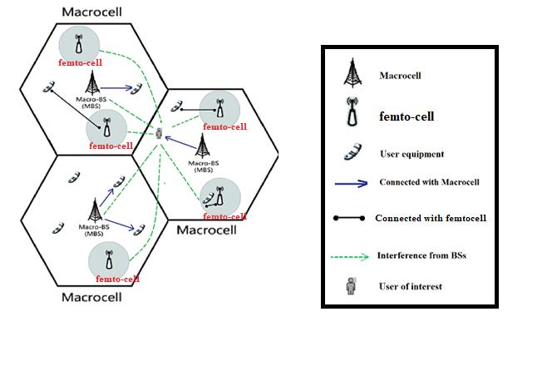

Figure . Network Architecture.

To determine the total Channels available in the spectrum, we assume an equal bandwidth per Channel, therefore we calculate the total Channels by using *Equation (‎3‑1)*.

|  |  |  |
| --- | --- | --- |
|  |  | *Equation (‎3‑1)* |

After that we combine a group of channels to form a Resource Block. The number of resources blocks is determined from the Cluster (Combine a group of macro Cells) size and the number of femto cells in each macro cell ( without reusing the resources blocks. The size of the resource block is determined from number of channels used for static allocation (calculated from the number of channels used for dynamic allocation , the total available channels ) and the total , where the number of Resources Block and size are calculated based on *Equation (‎3‑2)* and *Equation (‎3‑3)*.

|  |  |  |
| --- | --- | --- |
|  |  | *Equation (‎3‑2)* |
|  |  | *Equation (‎3‑3)* |

### Power Calculation:

The range for each cell should be calculated to know that the user can connect to the BS or not. Mathematically the range is calculated by *Equation (‎3‑4)* as [18] defines it. Where the constant in which [18] mathmetically calculats using the frequency as in *Equation (‎3‑5)*.

|  |  |  |
| --- | --- | --- |
|  |  | *Equation (‎3‑4)* |
|  |  | *Equation (‎3‑5)* |

Where: :Path loss

The power consumed by each user is differ than the transmitted power from the BS that the user connected with, and it can be calculated in different ways as in [19] , *Equation (‎3‑9)* was used based on [20] because it is the best equation that fit our topology where the Gains, the transmitted power and the wavelength are parameters and the distance is also calculated. Formally, for a given BS x and a desired MS y, the desired signal power received at y is calculated formally as in *Equation (‎3‑9)*.

|  |  |  |
| --- | --- | --- |
|  |  | *Equation (‎3‑6)* |
|  |  | *Equation (‎3‑7)* |
|  |  | *Equation (‎3‑8)* |
|  |  | *Equation (‎3‑9)* |

Where:

* and are the receive and transmit antenna gains.
* is the wavelength
* is the distance between x and y. (Euclidean)
* where d>d0
  + Typical value for :
    - Indoor:1m
    - Outdoor: 100m to 1 km
* is the transmitted power
* is the received power
* and are in same units
* and are dimensionless quantities.

### SINR Calculation:

The signal to interference ratio is a ratio between the average received signal and the average co-channel interference from other base stations that operates on the same frequency bands and it is calculated mathematically (SIR) as in *Equation (‎3‑10)* [20].

|  |  |  |
| --- | --- | --- |
|  |  | *Equation (‎3‑10)* |

Where are all Base stations that cause Interference with the base station the MS is connected to. we also considered the thermal noise denoting by , thermal noise is modeled here as an additive white Gaussian noise (AWGN). The variance is denoted by , and a mean of zero. The signal to interference noise ratio was calculated based on *Equation (‎3‑11)* [20].

|  |  |  |
| --- | --- | --- |
|  |  | *Equation (‎3‑11)* |

Where N is the terminal noise (additive white gaussian Noise).

### Throughput:

Total throughput is the product of the total number of active users and the average achievable rate of a randomly chosen user when it is under the coverage of the BS as in *Equation (‎3‑12)*. All throughput calculations where based on [12].

|  |  |  |
| --- | --- | --- |
|  |  | *Equation (‎3‑12)* |

Where:

∶ is the density of the randomly chosen user

: is the total area

: is the averaged coverage probability of mBSs over the plane

: is the averaged coverage probability of pBSs over the plane

: is the average achievable rate of the randomly chosen user in the Macro tier

: is the average achievable rate of the randomly chosen user in the Femto tier

To find the coverage probability, we use *Equation (‎3‑13)*

|  |  |  |
| --- | --- | --- |
|  |  | *Equation (‎3‑13)* |

Where:

* : Target SINR
* : the random distance between the tagged MU and its serving mBS
* , such that:
* : path loss exponent
* : Noise variance
* : mBS density

The averaged coverage probability of pBS over the plane is derived as in *Equation (‎3‑14)*.

|  |  |  |
| --- | --- | --- |
|  |  | *Equation (‎3‑14)* |

Where:

Now, the only thing remaining is to find the average achievable rate, the following equations(*Equation (‎3‑15)*, *Equation (‎3‑16)*, *Equation (‎3‑17)*, *Equation (‎3‑18)*and *Equation (‎3‑19)*) shows how to find it.

|  |  |  |
| --- | --- | --- |
|  |  | *Equation (‎3‑15)* |
| Where: |  | *Equation (‎3‑16)* |
|  |  | *Equation (‎3‑17)* |
|  |  | *Equation (‎3‑18)* |
|  |  | *Equation (‎3‑19)* |

Where LI1(s) and LI2(s) are the Laplace transform of a random variables 𝐼1 and 𝐼2 which are the aggregate interference power generated by the () at the tagged macro MU.

## Problem formulation and solution:

Our objective here is to find the maximum spectrum and energy efficiency while considering the load balancing of users in the network and minimum number of transitions between cells. At first, we can define the spectrum efficiency as the total throughput divided by the total bandwidth, the energy efficiency as the total throughput divided by the total power consumption, and the load balancing by maximizing the number of users connecting to the femto cell while minimizing the number of uses connecting to the Macro cell. Now, we can express the spectrum and energy efficiency according to the definition above as spectrum efficiency in *Equation (‎3‑20)* and energy efficiency in *Equation (‎3‑21)*.

|  |  |  |
| --- | --- | --- |
|  |  | *Equation (‎3‑20)* |
|  |  | *Equation (‎3‑21)* |

Based on the above analysis, we formulate an optimization problem to balance SE and EE, to maximize the SE under the EE constraint. This optimization problem can be formulated as:

|  |  |  |
| --- | --- | --- |
|  |  |  |
|  |  |  |
|  |  |  |
|  |  |  |
|  |  |  |
|  |  |  |
|  |  |  |
|  |  |  |
|  |  |  |
|  |  |  |
|  |  |  |
|  |  |  |
|  |  |  |

## Solving the Problem Using Greedy Single Objective Game Theory Approach

The simple greedy algorithm will use one main objective without considering the other objectives to associate the users to the base station, while on the other hand the game theory approach will associate the users by combining more than one objective into one value which will make the decision based on multiple objectives.

### Simple Single Objective Greedy Algorithm:

In this method we will associate the users based on the calculated SINR and the received power for each user using a simple greedy algorithm which will associate the user on the maximum SINR only or the maximum POWER received only or by maximizing the connected users on the femto base stations and minimizing the connected users on the macro cell. where the SINR is represented by the spectrum efficiency and the power is represented by the energy efficiency and tacking into account the number of users that are connected to the base station which is represented by the load balancing. Algorithm 1 shows how to associate the users based one objective using simple greedy algorithm. And Algorithm 2 shows how to associate the users based one objective with load balancing.

|  |  |
| --- | --- |
| **Algorithm 1** Simple Greedy Algorithm Power and SINR allocation | |
|  | ***for*** *user* ***do*** |
|  | ***find*** *all possible base-stations that user can connect to.* |
|  | ***for*** ***do*** |
|  | (1) Calculate the Power according to *Equation (‎3‑9)* |
|  | (2) Calculate the SINR according to *Equation (‎3‑11)* |
|  | **end for** |
|  |  |
|  | *Power allocation* |
|  | ***find*** maximum power from *all possible base-stations that user can connect to* |
|  | ***check*** if Possible to connect to base station ***(Capacity)*** |
|  | ***if not*** |
|  | ***remove*** that possible connection and repeat from (8) |
|  | ***end if*** |
|  | ***if Possible*** |
|  | ***Assign*** the user to maximum power received |
|  | ***end if*** |
|  |  |
|  | *SINR allocation* |
|  | ***find*** maximum power from *all possible base-stations that user can connect to* |
|  | ***check*** if Possible to connect to base station ***(Capacity)*** |
|  | ***if not*** |
|  | ***remove*** that possible connection and repeat from (8) |
|  | ***end if*** |
|  | ***if Possible*** |
|  | ***Assign*** the user to maximum power received |
|  | ***end if*** |
|  | ***end for*** |

|  |  |
| --- | --- |
| **Algorithm 2** Simple Greedy Algorithm Load Balancing | |
|  | ***for*** *user* ***do*** |
|  | ***find*** *all possible base-stations that user can connect to.* |
|  | ***for*** ***do*** |
|  | (1) Calculate the Power according to *Equation (‎3‑9)* |
|  | (2) Calculate the SINR according to *Equation (‎3‑11)* |
|  | **end for** |
|  | **Sperate** Macro Base stations into and Femto base station into |
|  | **set** |
|  |  |
|  | *Load Balancing allocation Based on Power/SINR* |
|  | ***sort descending*** *based on Power/SINR* |
|  | ***for*** ***do*** |
|  | ***check*** if Possible to connect to base stationj ***(Capacity)*** |
|  | ***if not*** |
|  | ***remove*** that possible connection and repeat from (11) |
|  | ***end if*** |
|  | ***if Possible*** |
|  | ***Assign*** the user to the femto base station |
|  | **set** |
|  | **break** |
|  | ***end if*** |
|  | ***end for*** |
|  |  |
|  | **If** flag ≠ 1 |
|  | ***sort descending***  *based on Power/SINR* |
|  | ***for*** ***do*** |
|  | ***check*** if Possible to connect to base stationj ***(Capacity)*** |
|  | ***if not*** |
|  | ***remove*** that possible connection and repeat from (24) |
|  | ***end if*** |
|  | ***if Possible*** |
|  | ***Assign*** the user to the femto base station |
|  | **break** |
|  | ***end if*** |
|  | ***end for*** |
|  | ***end if*** |
|  | ***end for*** |

We take one user per time, we see all possible base-stations that the user can connect and find the SINR and power for each base station, then on the objective we want we associate the user to the base station we find the maximum objective we choose and check if the base station is not full and has a place for the user to connect to it and associate the user to the first base station that is not full. For load balancing, we start by checking all femto cells separately and connect to the femto cell if possible, and if not possible, then we will switch by checking the macro cell base stations.

### Game Theory Algorithm

Game theory is a mathematical modeling tool, which tries to distribute the interest to all interaction players(Users) by reach a point called "equilibrium point". This happens when users take the best strategy to be associated with only one BS.

In HetNets, the process of spectrum and energy-efficiency user association based on the Game Theory can be described as follows. The Game theory has two main approaches:

* Cooperative approach: Each player in the game considers the utility of the rest of players when he tries to maximize its own utility. On other words the players on the network agree to work together and divide the gains based on their individual contributions.
* Non-Cooperative approach: In this approach there will be some winners and losers between players. Where, each user tries to maximize its own utility no matter what other players (opponents) decides to do.

### Problem Formalization for Game Theory:

Players:

Game Theory describes each user or BS as a player and in our topology the users were assumed to be the players.

Each UE in a specific area that is served (by Macro or Femto) is denoted as a player. Assume that M users, each one of them has a selection {… … }. Each UE can choose to be associated with any BS within the range. Therefore, each UE in this range can be modeled as a player of the Game Theory.

Strategy:

The strategy in game theory of each user refers to the selection of a BS where, each UE can select any BS to be associated with.

The Probability of each to selects can be denoted as , since ∈ {0,1}, and . That means each user can be associated with only one BS.

Each user can connect with more than one BS needs to determine which BS to connect with by consider multi-objective (SINR, Power-Received, Load balancing).

For the SINR we collect the best SINR for each user, whereas the minimum SINR that allows the user to connect with a BS should be greater than (0.2), otherwise the user will not be considered. Then store the users SINR values in an array and find the mean value of all SINR values for all users. At the same way we find the mean value of power.

Now the distributions for each user () should follow *Equation (‎3‑22)*.

|  |  |  |
| --- | --- | --- |
|  |  | *Equation (‎3‑22)* |

Normalizing SINR and PR:

The values of SINR and PR are not in the same range, so we need to scale them to be close to each other. To do that we normalize these quantities using *Equation (‎3‑23)* and *Equation (‎3‑24)*.

|  |  |  |
| --- | --- | --- |
|  |  | *Equation (‎3‑23)* |
|  |  | *Equation (‎3‑24)* |

Where STD means the standard deviation, for both (SINR, PR) calculated as in *Equation (‎3‑25)*:

|  |  |  |
| --- | --- | --- |
|  | σ (STD) | *Equation (‎3‑25)* |

where, for each value, subtract the mean and square the result, then work out the mean of those squared differences and take the square root of that and we are done. The normalized value for SINR and PR will differ in each run and applied to previous equations.

We should notice that the value of (V) is not enough because it can give us greedy search of BSs that gives the best possible value from the array, so we need to consider the load balancing as the 3rd objective in our decision.

Load Balancing Objective:

The load balancing objective is implemented by considering the BS capacity, where the BS should not be full to allow some users to connect with it when necessary and take into account the number of connected user and the value of V (SINR with the power) as ratio.

Each user ( ) can see more than one BS, the decision is determined by dividing the value of V over the number of connected users for each BS, and the best result we get will determine which BS the user will connect with. See *Equation (‎3‑26)*.

|  |  |  |
| --- | --- | --- |
|  |  | *Equation (‎3‑26)* |

that the user can connect with. So that, our decision takes these 3 objectives to assign any user to a specific BS.

Utility function:

The utility function is calculated after assigning each user to a BS, depending on multiple objectives (SINR, Power received, Load-balancing), and it can be calculated in different ways. In our topology the utility for each user was calculated as the ratio of the throughput over the SINR as the equation below. And the payoff (gain) of a player is determined by its net utility.

|  |  |  |
| --- | --- | --- |
|  |  | *Equation (‎3‑27)* |

where i ∈ {UE}. and the total utility can be calculated as in *Equation (‎3‑28)*.

|  |  |  |
| --- | --- | --- |
|  |  | *Equation (‎3‑28)* |

where M number of user connected.

## Solving Problem Using Evolutionary algorithm:

In this section we will formalize our problem to solve it using Evolutionary algorithm (Genetics algorithm). In which it will give us a possible solution which is as much close to the optimal solution for the topology we formalized. In the next part we will describe the chromosome we will use, moreover will describe the genes for the chromosome and define our fitness function that will be used in the genetics algorithm and solve the problem as single objective genetics algorithm problem and multi-objective genetics algorithm using Non-dominant Sorting Genetics Algorithm (NSGA-III).

### Problem Formalization for Evolutionary Genetics:

#### Chromosome Formalization:

As we made the Macro cells, the Femto cells and the users, numbers and locations as random as possible then also the chromosome will be affected by these changes from one topology to another. Which will make it changeable (dynamic) between topology and another.

In the same topology the chromosome will be static which will contain all users in the topology that are inside the area of our system and can connect to a macro cell or a femto cell. The chromosome will be as shown in Figure ‎3.2. Each user describes a gene of this chromosome and the crossover will be as changing genes of this chromosome.

|  |  |  |  |  |  |  |
| --- | --- | --- | --- | --- | --- | --- |
|  | | | | | | |
| User 1 | User 2 | … | User k | … | User (i-1) | User i |

Figure . Our Chromosome for NSGA-III Algorithm

#### Genes Formalization:

As we mentioned before the chromosomes will contain the genes which are the number of users that can connect to our network, but each gene will contain all the possible base stations that a user can connect to. As the number of base stations that a user can connect to is changeable from each user to another then in this way the genes also will be changeable in the one chromosome which will affect the crossover, so in order to unify the genes over the chromosome then we will separate the genes into two sub-genes, the first will contains only the Macrocells possible connections and the second will contain the Femto cells possible connection, then we unify these numbers for all the genes and take the maximum number of macro base stations and the maximum number of femto cells a user can connect to and define the genes as the total number of base stations a user can connect to. Figure ‎3.3 Shows the description of the genes. Each part of the gene will be either a 0 or 1 (Binary) (1: the user is connected to this base station, 0: user isn’t connecting to this base station) and for the one gene at most and at least one of its parts will be 1 which means that the user is only connected to one base station. Moreover, the genes consist of the cell Id as shown in Figure ‎3.3 (Cluster Id , Macrocell Id and Femtocell Id (will be described later in the next chapter)).

|  |  |  |  |  |  |  |  |
| --- | --- | --- | --- | --- | --- | --- | --- |
|  | | | | | | | |
| Possible Macro Cell 1 | Possible Macro Cell 2 | … | Possible Macro Cell M | Possible Femto Cell 1 | Possible Femto Cell 1 | … | Possible Femto Cell F |

Figure . Our Genes for NSGA-III and genetics Algorithms

#### Cross-Over Algorithm:

The cross over will happen between any two members of the population where each matting will produce two new members which we will call children that may have a better qualities than their parents, the cross over will be an exchange of genes between the parents, the place of the genes will remain static so if the first gene transfer from the first parent then it must replace the first gene in the second parent and so on for all genes in the chromosomes, the number of genes to be transferred and the place of genes will be chosen randomly.

This process will be repeated for the number of iterations which is an input for the algorithm and if the system falls in some local maxima then a mutation will help us to get out of this solution.

#### Generating population:

The generation for a population will be randomly as each gene in the chromosome will be generated separately, where there is a constrain on the generation process, that each bit in the gene that represents a possible connection, although the user cannot be connected to more than one base station and the user must be connected to at least one base station, so there must be at least and at most one bit in the gene that is one to insure that the user is connected to a base station and no more than one. The generation process is randomly so that in the population there must be all possible scenario, and for the base stations that are padded to the gene and the user cannot connect to them, then these must not be ones so to ensure that the user isn’t connected to a base station that he from the first cannot connect to it.

#### Probability of matting:

When we choose two chromosomes to be matted then there is a probability that these chromosomes can be matted and produce two new children. This probability must be high enough to make the process faster and to reach the optimal solution. This probability must be greater than 70% and in the best case it can reach to 100% where for each possible choice there is a mating and two new children are created.

#### Probability of mutation:

In this section we will describe the mutation process that may occur in the children chromosomes after the cross over happens, where one gene in the chromosome can be changed and this changing also has some constrains, as if a mutation occur then it will change the one to zero and set one of the possible zeros that represents a possible base station the user can connect to, the probability of a mutation is low and it is less than 1%.

#### Fitness Function:

Our fitness function was calculated for each chromosome independently, described by *Equation (‎3‑29)*.

|  |  |  |
| --- | --- | --- |
|  |  | *Equation (‎3‑29)* |

Where gene is connecting with the base station or not, is the objective that is used for that base station and the desired user, and N is the number of genes in the chromosome, so we will compare using multi objectives as SINR, Power, and the Load balancing.

### Evolutionary Algorithm Based on Single Objective Value:

In this section we will describe how to calculate the fitness function using SINR only, Using Power only, Using Power and SINR, and using Power, SINR and load balancing. For single objective evolutionary algorithm.

#### Using SINR only:

In this technique we will calculate the SINR for each user and each base station that can connect to, and we will calculate the fitness function for each chromosome by adding the SINR for each user for the base station that is connecting to; according to that chromosome.

#### Using Power only:

In this technique we will calculate the received Power for each user and each base station that can connect to, and we will calculate the fitness function for each chromosome by adding the Power for each user for the base station that is connecting to; according to that chromosome.

#### Using Power and SINR without load balancing:

This technique is different for the above since the SINR and Power may have different means and standard deviation, so adding them may result by one dominate the other, which will be dominant for one objective. So, to solve that problem we should change the mean and standard deviation for both the SINR and Power to the same mean and standard deviation to add them using *Equation (‎3‑30)* where both are equally weighted. To make an array named Var distributed between 0 and 1 we will use *Equation (‎3‑31)* and *Equation (‎3‑32)*.

|  |  |  |
| --- | --- | --- |
|  |  | *Equation (‎3‑30)* |
|  |  | *Equation (‎3‑31)* |

Where is the weight for each objective takes the values from 0 to 1 so we took =0.5 which means they are equally weighted, the Var is an array of the numbers (SINR or Power) for all possible connection cells for one user. Normalized.Var is an array of the new normalized Var in the range of where 99.9% of all the Var values in this range, so to make the range from (0,1) with mean 0.5 we used *Equation (‎3‑32)*.

|  |  |  |
| --- | --- | --- |
|  |  | *Equation (‎3‑32)* |

Dividing by 6 will change the range from to ( with zero mean and adding 0.5 to the array will change the mean from 0 to 0.5 and the range from to . Applying the above equations for the SINR and Power Arrays this will unify the mean and the standard deviation for the SINR and Power, (Mean= 0.5 and Unity Standard deviation). This allows us to add the arrays using *Equation (‎3‑30)* which will result for a new array distributed between with mean=1 and standard deviation equal 2.

After adding the SINR and Power arrays we will calculate the fitness function for each chromosome by adding the Normalized array (SINR + Power) for each user for the base station that is connecting to (its Bit is 1); according to that chromosome.

#### Using Power, SINR and Load balancing:

Adding the load balancing for our calculation is made by dividing the Normalized Power and SINR by the number of users connecting to that base station. *Equation (‎3‑33)* shows how it is done.

|  |  |  |
| --- | --- | --- |
|  |  | *Equation (‎3‑33)* |

And After adding the load balancing to the SINR + Power arrays we will calculate the fitness function for each chromosome by adding the Normalized array with the balancing () for each user for the base station that is connecting to (its Bit is 1); according to that chromosome.

### Evolutionary Algorithm Based on Multi objective Solution:

Multi-objective optimization can be used for solving our problem, in which we can determine the objective values we want and with an algorithm we can make a trade of between more than one objective and to get a set of better solutions that maximize or minimize our solutions than the single objective optimization. In a way we will not look at the problem as a single objective problem and focus on one main objective and discard the other objectives but make a trade of between many objectives and get a better solution. So, multi-objective optimization will make each objective as a separate single objective.

To solve our problem, we used the proposed algorithm NSGA-III (Non-Dominant Sort Genetics Algorithm) as proposed in (paper) for our chromosome and solved the problem for the main two objectives SINR and received power. The NSGA-III has three main features, first it uses an exclusive principle, secondly it emphasizes non-dominated sorting solutions which it will sort the solution arrays in a way that if a solution is better than a solution by all objectives it will remove the worst solutions. Finally, it uses an explicit diversity preserving mechanism.

The fitness function we proposed for each objective is described in ‎3.5.1.7 above which is calculated for each objective separately. So, the fitness function for the SINR will be calculated formally as in *Equation (‎3‑34)* and the power calculation fitness function is mathematically calculated as in *Equation (‎3‑35)*.

|  |  |  |
| --- | --- | --- |
|  |  | *Equation (‎3‑34)* |
|  |  | *Equation (‎3‑35)* |

Where describes the gene is connecting with the base station or not, and is the objectives that are used for that base station and the desired user, and N is the number of genes in the chromosome, so we will compare using multi-objectives SINR, and Power.

#### Adding the load balancing to the multi objective solving problem:

We also can add the load balancing to the multi objective problem and define a fitness function for the load balancing, this work can be made as a future work by adding the load balancing objective for the NSGA-III algorithm, making our decision on main three objectives which are, the SINR, the Power and the load balancing. The fitness function for the load balancing is calculated in *Equation (‎3‑36)* making the number of users connecting to the femto cell much more than the users connecting to the macro cell.

|  |  |  |
| --- | --- | --- |
|  |  | *Equation (‎3‑36)* |

want to achieve is maximizing the Load-balancing objective by maximizing the number of users connecting to the femto base station and minimizing the number of users connecting to the macro cell as shown in *Equation (‎3‑37)*.

|  |  |  |
| --- | --- | --- |
|  |  | *Equation (‎3‑37)* |

# Experiments and Results

## Simulation Tool:

The tool we used to build our topology and simulate the outputs is MATLAB, where, this software has a lot of helpful libraries and packaging with optimal complexity implementation to prepare our environment and optimization technique, where we implement the optimization method **(Genetic Algorithm)** using the **NSGA-III** which is already exist in MATLAB and we just formalize the problem to fit the implementation of NSGA-III. Moreover, the MATLAB is easy to implement GUI interface and fit it with the code.

## Experiments setup:

Building topology: In this section we will briefly summarize the topology and the parameters we are used in MATLAB.

### Building topology:

The topology was built to be dynamic. So that, we can add more than one tier and change the number of small cells and the area as a parameter. So, we can use more than one optimization technique at the same topology.

Also, the optimization metrics (SE, EE, Load-Balancing, minimum number of transitions) built to be dynamic which we can work on one metric or merge between two or more metrices at the same time Table ‎4‑1shows the main classes we used in the MATLAB codes.

Table ‑ MATLAB Classes and description

|  |  |
| --- | --- |
| Class name | Description |
| cluster | This class set up the clusters which contains the cluster ID, number of cells in each cluster and the position of the cluster. |
| Cell | This class defined for each cell in the cluster and it contains the cell ID, type (Macro, Femto), position, maximum capacity, number of resources blocks and the maximum range of it. |
| User | This class contains the ID of the user and the coordinates of the user (X axis and the Y axis) and the possible cells can connect to, Type (indication the type of cell that the user connect with), power received and the SINR. |
| SINR and Power calculation | In this class we calculate the power received from each user depending on different parameters then the SINR that depends on the power received and, in this class, we assign each user to a BS depend on the optimization technique used. |
| Resources Blocks | This class contains pool of resources blocks that distribute it to each cell. |
| Draw Topology | In this class we draw the topology after the distribution of user depending on one of the optimization techniques. |
| Total Throughput | In this class we determine the total throughput of the system to calculate the SE and EE. |

### Simulation Parameters:

In this section, we will check the validity of the results of our analysis through comparison of Game Theory simulation results and Genetic results. the simulation parameters we used are summarized as shown in Table ‎4‑2.

Table ‑ Parameters Values for Simulation

|  |  |  |
| --- | --- | --- |
| Parameters | Notation | Value |
| Area | A | 90 × 90 m2 |
| mBS Radius |  | 10Km |
| fBS Radius |  | 500m |
| Total bandwidth |  | 100MHz |
| Noise power |  | −120 dBm |
| Path loss exponent |  | 2 |
| mBS transmit power |  | 40W |
| fBS transmit power |  | 0.1W |
| mBS static power consumption |  | 400W |
| fBS static power consumption |  | 1w |
| mBS MU density |  | 0.01 |
| fBS MU density |  | 0.01 |
| Number of users | Nu | 500 |

The previous parameters have been used because they have been used in other sources as in [12] and we choose the same parameters to compare our results with [12].

## Results:

These results were formed and calculated using the MATLAB topology we built, the results were taken from MATLAB and drawn on excel.

### Determining the best Macro density

Figure ‎4.1 and Figure ‎4.2 explains the relationship between (Energy Efficiency/Spectral Efficiency) and the ratio of (Macro BS density to UE density) respectively, we considered the Femto Bs density to be equal to . From Figure ‎4.1 and Figure ‎4.2 we consider the tradeoff between spectral and energy efficiency we found that the best value of the ratio (Macro BS density to UE density) is 0.04.

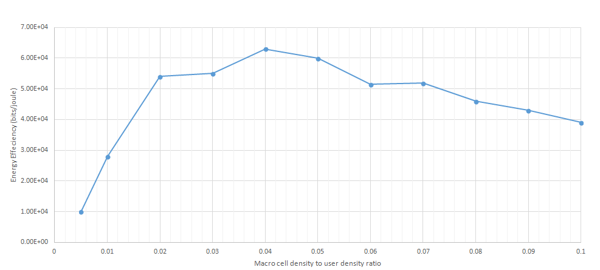

Figure . Energy efficiency bits/joule Vs. Macro cell density to user density ratio.

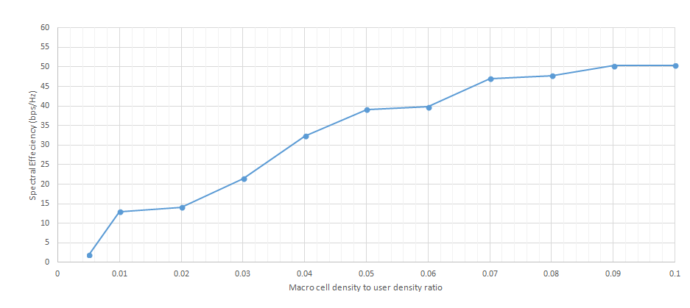

Figure . Spectral efficiency(bps/Hz) Vs. Macro cell density to user density ratio.

After we found the optimal ratio, now we can calculate the value of the Macro BS density which is equal to (0.04*UE density = 4*10-4) and use it as a parameter for all the optimization techniques.

We notice that the SE increased by increasing the ratio, this is because when the BS density increases, the network throughput will increase so that the SE will increase as well until it reaches a certain threshold it will increase slowly. The value of the EE depends on the total throughput and the power consumption, as the figures above we notice that the total throughput keeps increasing and by increasing the number of BSs the total power consumption will also increase. At first, the speed of throughput growth is faster than the speed of power consumption so that the EE increased until the speed of throughput growth becomes slower than the speed of power consumption then it starts decreasing.

### The impact of Number of small cells on the total throughput

Figure ‎4.3 shows the impact of increasing the number of small cells to the total throughput.

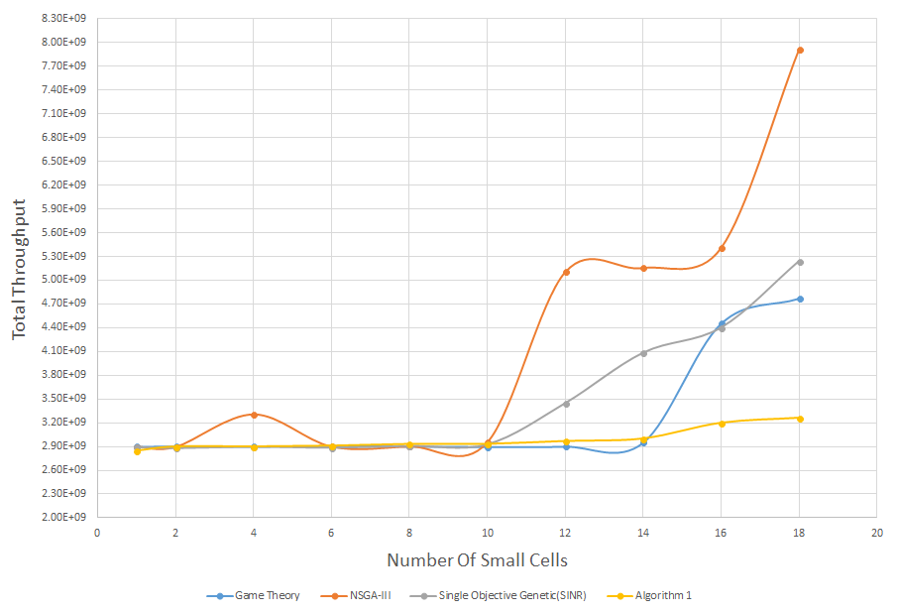

Figure . Number of Small Cells Vs Total Throughput all techniques.

We notice that, the total throughput increased proportionally as the number of small cells increased for all techniques. That’s because it offers more opportunities for the mobile user to be handed over to a small cell.

Form the Figure ‎4.3 the NSGA-III gives the highest system throughput then the single objective genetic then the game theory then the Algorithm 1, that’s return to the way of distributing the users over the small cells which is differs from technique to another.

### The impact of Number of users on the Energy Efficiency

Figure ‎4.4 shows the impact of increasing the number of users to Energy Efficiency (EE) as also from Figure ‎4.4 we notice that the EE increased until a certain threshold at first and that is due to the speed of throughput growth is faster than the speed of power consumption, then starts decreasing dramatically as the speed of throughput growth becomes slower than the speed of power consumption. Although, we notice that there is different threshold for the above techniques, for example the NSGA-III threshold was 200 users and that means it reach the maximum EE when 200 users are connected. In our topology we used 500 users as input and we found that our algorithm gives the best EE at this number of users.

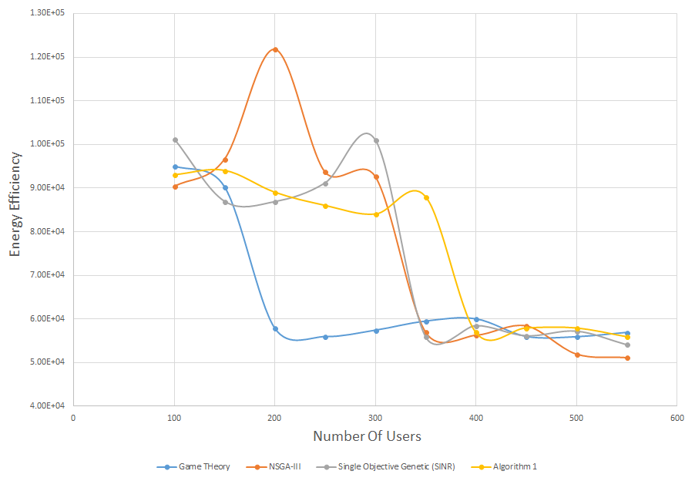

Figure . Energy Efficiency Vs Number of users all techniques.

### The impact of Area on the EE and SE

To determine the effect of area on the SE and SE, we had to make every parameter fixed except the area, we put the value of users as 500 users, the density of macro BS is 4*404 and the user, femto density and bandwidth as appear in Table ‎4‑2 in section (‎4.2.2). The values of area were given a range from 1600 to 12100 m2.

Figure ‎4.5 and Figure ‎4.6 shows the impact of increasing the topology area on the Energy Efficiency and Spectrum Efficiency.

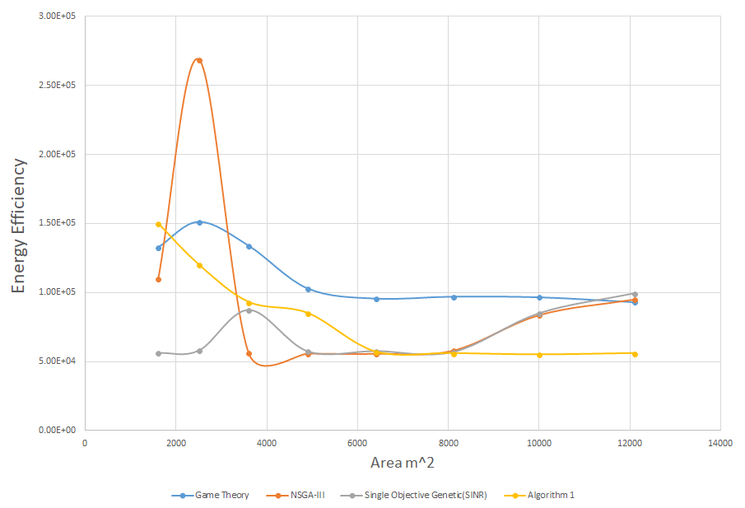

Figure . Area Vs EE all techniques.

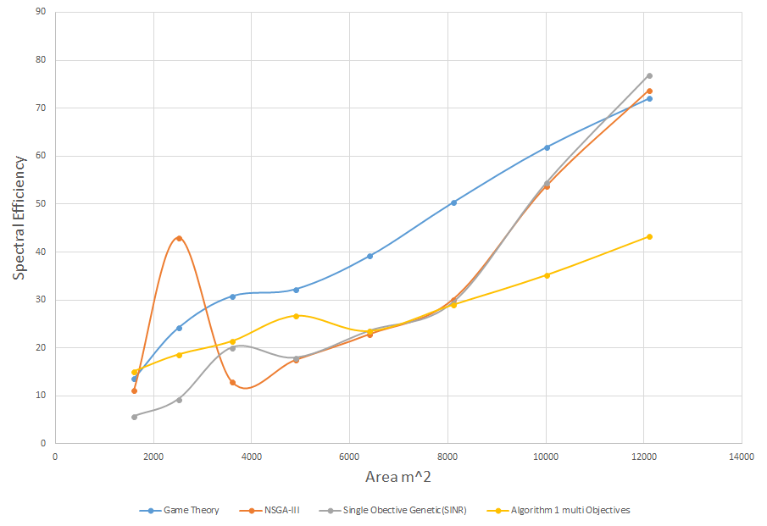

Figure . Area Vs SE all techniques.

We know from the above results shown in Figure ‎4.5 and Figure ‎4.6 that if we increase the number of users in the topology, the total throughput will be increased, and it will increase slowly when it reaches a certain level. And the total power consumption will increase when the number of users rise. Well, Figure ‎4.5 and Figure ‎4.6 above support this, by which when the total area of the topology increases it will increase the accepted users in the topology and so the throughput and power consumption will be increased. That makes the spectrum efficiency increases as the area increases as appears in Figure ‎4.6, we notice that when the area is small (1600m2) our algorithm (the yellow line -lowest line-) has the best spectral efficiency but as we increase the area the other techniques will improve more than it because as we saw from the previous results our algorithm gives a small improvement in throughput as number of users increases. For EE, Figure ‎4.5 makes sense because the number of users increased so the total power consumption is also increased so that the energy efficiency decreased in all techniques.

Our topology appears as the best when the area under 5000m2, but above that level the other techniques will overpass our proposed algorithm because their throughput values will be higher than ours. From Figure ‎4.5 and Figure ‎4.6, we notice that the game theory gives the best values in the spectral and energy efficiency domains, well that makes sense because it is a cooperative technique that seeks for the biggest utility of the system.

### Flow chart describes the percentage distribution across all macro and femto cells for each optimization technique

Figure ‎4.7 below shows the percentage of users connected over macro or femto cells. From the flow chart shown in Figure ‎4.7 we notice that the game theory gives the best exploit of femto cells which is near half percent of users will connected to femto and the rest half connected with macro cells. The rest of algorithm, the users connected with macro cells have more percentage than the number of users connected with femto cells.

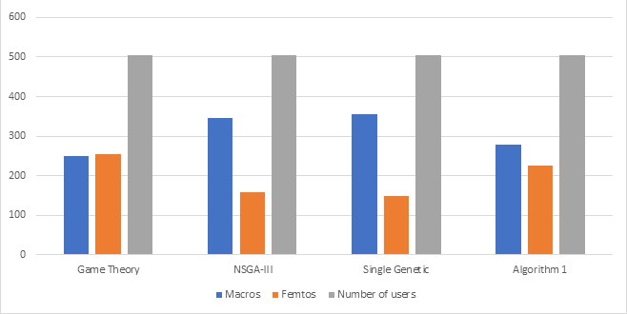

Figure . distribution of near 500 users over macro and femto cells.

### Run samples for the optimization techniques shows the distribution of users in our topology.

In this section we will display the distribution of results for users for each of the methods used game theory as in Figure ‎4.8, single objective genetics as in Figure ‎4.10, multi objective genetics NSGA-III as in Figure ‎4.11 and greedy Algorithm .

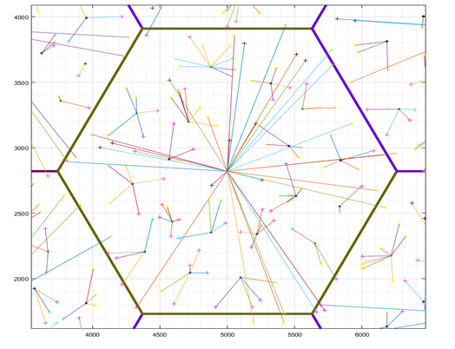

Figure . the distribution of users using Game Theory approach.

And the utility function defined as the throughput divided by the SINR compared with based line as shown in Figure ‎4.9.

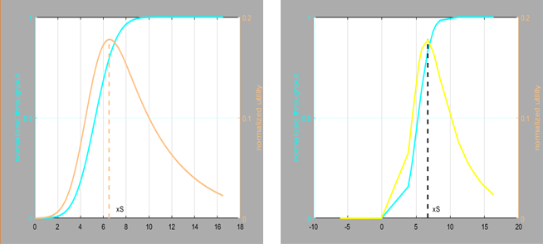

Figure . The utility function of Game Theory compared with the normal based line.

From the Figure ‎4.9, the right-side capture describes the utility function line compared to the normal line in the left. The utility function describes as the throughput over the SINR value. We notice that the Game Theory utility line was close enough to the base line and the optimal SINR value around the value equal 6.

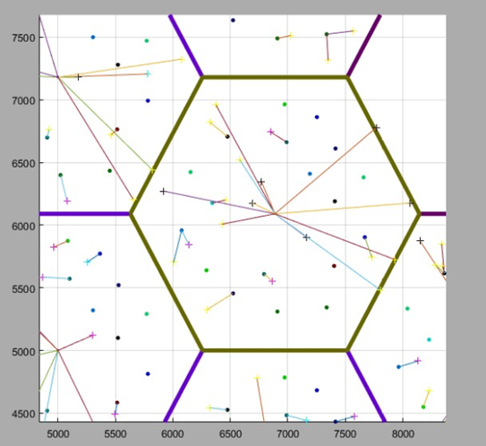

Figure . the distribution of users using Genetic Single objective.

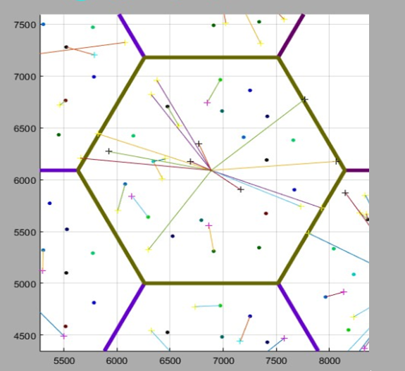

Figure . The distribution of users using NSGA-III.

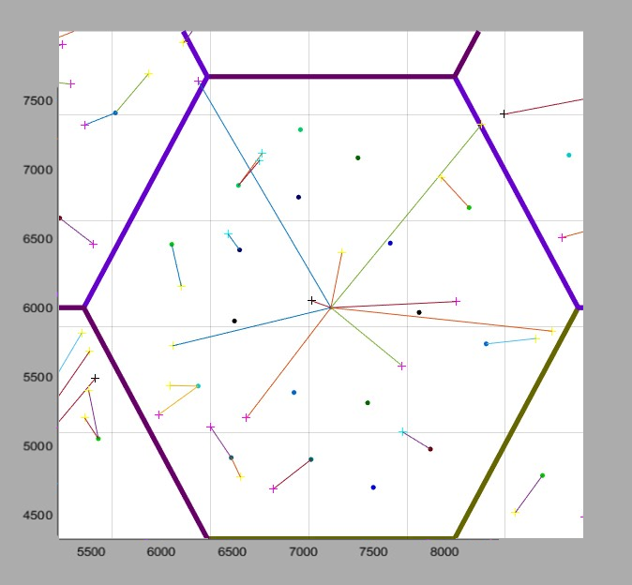

Figure . the distribution of users using Greedy Algorithm .

### Optimization techniques summary

Table ‎4‑3 below summarizes the optimization techniques results.

Table ‑ Optimization techniques summary.

|  |  |  |  |  |
| --- | --- | --- | --- | --- |
| Method used | number of small cells Vs Total Throughput | Number of users Vs (EE) | Area Vs EE | Area Vs SE |
| Game Theory |  |  | X | X |
| NSGA-III | X |  |  |  |
| Genetic single objective(SINR) |  |  |  |  |
| Algorithm 1 |  | X |  |  |

# Conclusion

The dramatic increase of mobile users connected on the network was the main reason to build a multi-tier HetNets. By deploying many small cells on the network, we increase the opportunity that a mobile user can be handled by a small cell and that will increase the throughput and reduce the latency.

In this report, the effect of macro BSs densities on the SE and EE of two-tier HetNets has been studied. SE and EE needed to be balanced to achieve a better network performance. Where, we found out the optimal BS densities that gives a good value for both SE and EE.

We studied the effect of the number of mobile users and the total area of the topology on Spectral Energy efficiency and load balancing, we saw that when we increase the total number of users or increasing the total area the throughput will grow well but it starts to increase slowly when it reaches a certain threshold. For the energy efficiency, the total power consumption will increase when new users are added, and the energy efficiency will start to decrease.

We used different optimization techniques (NSGA-III, Single objective genetics, Game theory and greedy algorithm), we saw that NSGA-III is better used when we want more throughput and SE in the network, Game theory and our algorithm is better when we want more EE.

The tendency of each optimization techniques to make users connect with a macro or femto cell was also studied, we saw that the game theory has the highest tendency to make users connect with femto cells and that what makes it good in terms of energy, but NSGA-III and single objective genetics have had the highest tendency to make users connect with macro cells and that what make them better in terms of spectrum efficiency.

At last, greedy algorithm was the best in terms of EE when the total area is under 5000m2, and when the number of connected users doesn't exceed 550 in the cell user.

# References

|  |  |
| --- | --- |
| [1] | N. Panwar, S. Shantanu and A. K. Singh, "A Survey on 5G: The Next Generation of Mobile Communication," *Physical Communication,* vol. 18, no. 3, pp. 64-84, 2016. |
| [2] | D. Lopez-Perez, I. Guvenc, G. De la Roche, M. Kountouris, T. Q. Quek and J. Zhang, "Enhanced Intercell Interference Coordination Challenges in Heterogeneous Networks," *IEEE Wireless Communications,* vol. 18, no. 3, pp. 22-30, 2011. |
| [3] | E. Seidel, "Carrier Aggregation Based Interference Coordination for LTE-A Macro-Pico HetNet," *Nomor Research GmbH,* vol. 77, no. 4, pp. 1-6, 2013. |
| [4] | E. Björnson, E. G. Larsson and T. L. Marzetta, "Massive MIMO: 10 Myths and One Grand Question," *arXiv,* vol. 7, no. 5, pp. 1503-1602, 2015. |
| [5] | G. N. Kamga, M. Xia and S. Aïssa, "Spectral-Efficiency Analysis of Massive MIMO Systems in Centralized and Distributed Schemes," *IEEE Transactions on Communications,* vol. 64, no. 5, pp. 1930-1941, 2016. |
| [6] | O. El Ayach, S. Rajagopal, S. Abu-Surra, Z. Pi and R. Heath, "Spatially Sparse Precoding in Millimeter Wave MIMO Systems," *IEEE transactions on wireless communications,* vol. 13, no. 3, pp. 1499-1513, 2014. |
| [7] | E. Hossain and H. Monowar, "5G Cellular: Key Enabling Technologies and Research Challenges," *IEEE Instrumentation & Measurement Magazine,* vol. 18, no. 3, pp. 11-21, 2015. |
| [8] | A. Brandenburger, "Cooperative Game theory: Characteristic Functions, Allocations, Marginal Contribution," *Stern School of Business. New York University,* vol. 1, no. 1, pp. 1-6, 2007. |
| [9] | M. Mitchell, An Introduction to Genetic Algorithms, London, England: MIT press, 1998. |
| [10] | J. Zuo, J. Zhang, Y. Chau, J. Wei and L. Wu, "Energy Efficient User Association for Cloud Radio Access Networks," *IEEE Access,* vol. 4, no. 1, pp. 2429-2438, 2016. |
| [11] | D. Liu, W. Lifeng, C. Yue, M. Elkashlan, K.-K. Wong, R. Schober and L. Hanzo, "User Association in 5G Networks: A Survey and an Outlook," *IEEE Communications Surveys & Tutorials,* vol. 18, no. 2, pp. 1018-1044, 2016. |
| [12] | L. Xiang, H. Chen and F. Zhao, "Area Spectral Efficiency and Energy Efficiency Tradeoff in Ultradense Heterogeneous Networks," *Wireless Communications and Mobile Computing,* vol. 2017, no. 1, pp. 8-16, 2017. |
| [13] | T. Han, G. Mao, Q. Li, L. Wang and J. Zhang, "Interference Minimization in 5g Heterogeneous Networks," *Mobile Networks and Applications,* vol. 20, no. 6, pp. 756-762, 2015. |
| [14] | M. Chinipardaz and M. Noorhosseini, "A Study on Cell Association in Heterogeneous Networks with Joint Load Balancing and Interference Management," *Telecommunication Systems,* vol. 66, no. 1, pp. 55-74, 2017. |
| [15] | Q. Ye, B. Rong, Y. Chen, M. Al-Shalash, C. Caramanis and J. Andrews, "User Association for Load Balancing in Heterogeneous Cellular Networks," *IEEE Transactions on Wireless Communications,* vol. 12, no. 6, pp. 2706-2716, 2013. |
| [16] | H. Wang, L. Ding, P. Wu, Z. Pan, N. Liu and X. You, "Dynamic Load Balancing and Throughput Optimization in 3gpp Ite Networks," in *Proceedings of the 6th international wireless communications and mobile computing conference*, Caen, France, 2010. |
| [17] | H. Velayos, V. Aleo and G. Karlsson, "Load Balancing in Overlapping Wireless LAN Cells," in *2004 IEEE International Conference on Communications*, Paris, France, 2004. |
| [18] | J. Arthur, "Designing a WiMAX Communication Network for ACCRA for Brondband Wireless Access," *International Journal of Advanced Research in Computer Engineering & Technology,* vol. 5, no. 4, pp. 15-30, 2016. |
| [19] | I. Nasim and S. Kim, "Human Exposure to RF Fields in 5G Downlink," *arXiv preprint,* vol. 16, no. 2, pp. 65- 71, 2017. |
| [20] | J. Aldhaibani, Y. Abid and A. Badlishah, "Coverage Extension and Balancing the Transmitted Power of the Moving Relay Node at LTE-A Cellular Network," *The Scientific World Journal,* vol. 2014, no. 3, pp. 11-21, 2014. |